PRELIMINARY EXAM GOAPPLE

JAMES QUINTERO MOSQUERA

GIORGI JULIÁN ORDOÑEZ

ING. ROBINSON GOMEZ

BASE TECHNOLOGIES: HTML, CSS, JAVASCRIPT, PHP AND MYSQL

MODALITY: GROUP DEVELOPMENT

FESC HIGHER EDUCATION FOUNDATION

CLIENT-SERVER ARCHITECTURE
SAN JOSE DE CUCUTA
09 DE MARCH DE 2026
ENGLISH VERSION

PRACTICAL GUIDE No. 1: BUSINESS DEFINITION AND WEB STRUCTURING

Activity 1: Software Scenario Planning
The GoApple POS project — Web Inventory and Point of Sale (POS) System — is a technological solution for the commercial management of small and medium-sized businesses, developed during the academic semester.
The system integrates the following modules:
• Product and inventory management in real time.
• Sales (POS) and purchase recording.
• Automatic invoice generation.
• User administration with differentiated roles.
Since the system allows simultaneous operation by multiple users (several cashiers recording sales at the same time), a model is required where critical validations and inventory control are executed in a centralized manner. A monolithic architecture would generate stock inconsistencies under concurrent sales and would pose a risk of data loss.
For these reasons, GoApple POS is designed under a distributed client-server architecture, where the interface, business logic, and database are physically separated into distinct nodes connected by network, ensuring:
• Transactional integrity
• Concurrency control
• Information security
• Future scalability

Activity 2: Structural Analysis and Layer Modeling

Technical Evaluation — 3-Layer Model
GoApple POS operates under a 3-layer model: presentation, business logic, and data.

Layer | Description
Presentation | Web browser with HTML, CSS, and JavaScript. Sends HTTP requests to the server.
Business Logic | PHP Server: inventory validation, total calculation, sales confirmation, user authentication.
Data | MySQL: stores products, sales, purchases, and users with referential integrity and transactions.

Design Metrics
Latency:
HTTP communication introduces minimal latency, optimizable through SQL queries with efficient indexes.
Coupling:
The system presents low coupling: the interface does not depend directly on the database but on the intermediate PHP layer, allowing the DB to be modified without affecting the UI.
Scalability:
The architecture allows horizontal scalability: the web server can be replicated for higher traffic and the DB can be optimized without altering the presentation layer.

Activity 3: Delimitation of Remote Business Processes

Server Logic (PHP)
The web server executes the following critical processes:
• Validation of data sent from the client.
• Processing of information received via HTTP requests.
• Transformation and serialization of data in JSON format.
• Communication with MySQL for information storage and retrieval.
• Generation of dynamic responses sent to the user's browser.

Client Logic (Web Browser)
The client runs in the browser the interface built with:
• HTML — interface structure.
• CSS — visual design.
• JavaScript — interaction and sending of HTTP/AJAX requests to the server.
Its main functions are to capture user data, send it to the server, and render the received responses.

Activity 4: Payload Design and Sequence Diagram

Data Structure (Payload)
Communication between client and server is carried out via JSON over HTTP:

{
"servicio": "Auth_Global",
"status": "Connected",
"latencia": "20ms"
}

On the PHP server, the data is processed with json_decode(), transforming the JSON string into a manipulable object.

Request / Response Communication Flow
1. The user accesses the website from their browser.
2. The browser sends an HTTP request to the server.
3. The server executes the corresponding PHP script.
4. The PHP script processes the received data (JSON).
5. The server generates a response and sends it to the client.
6. The browser receives the response and displays the result to the user.

EVIDENCES

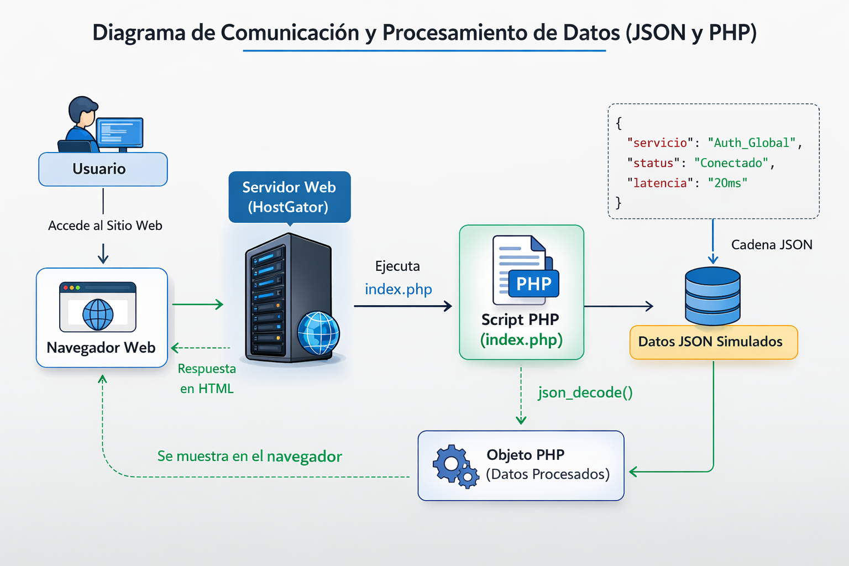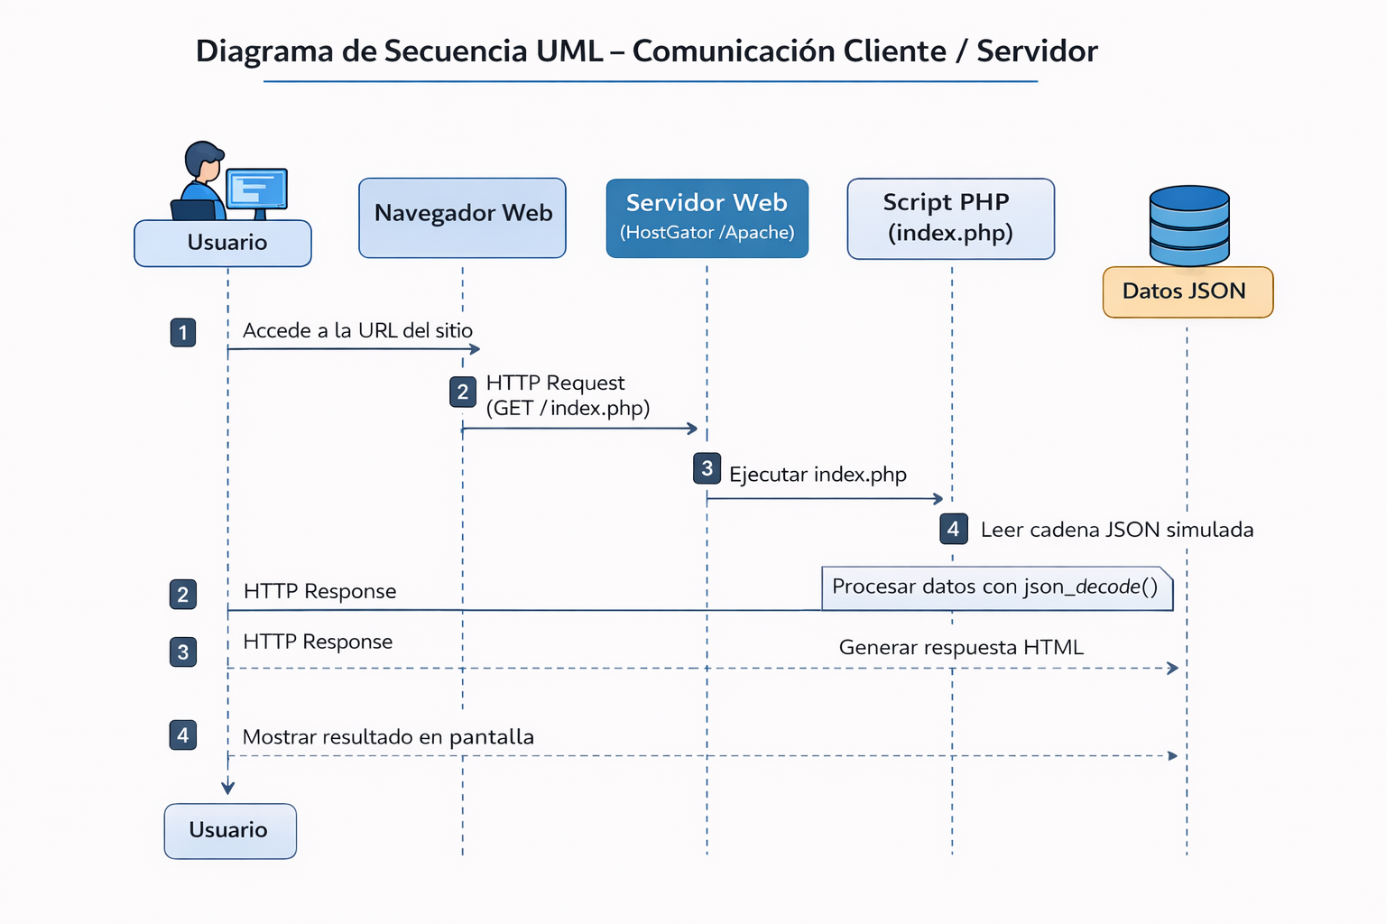
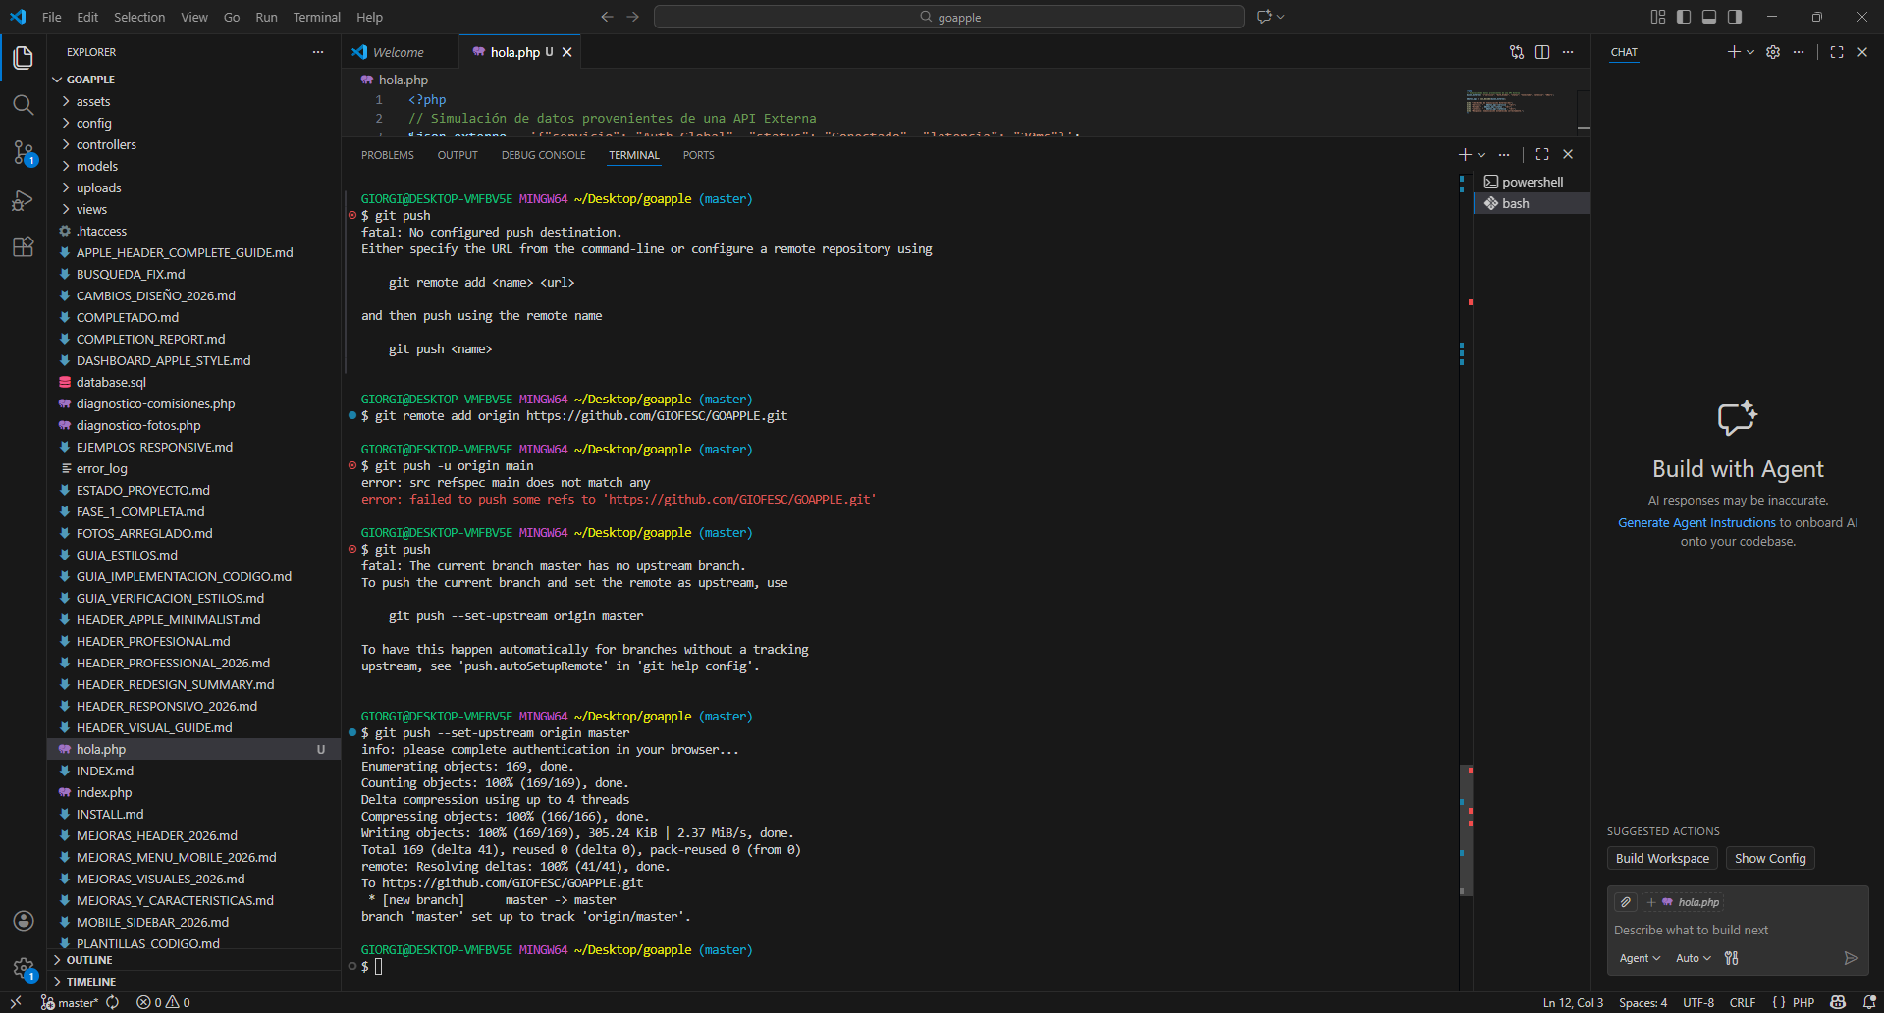
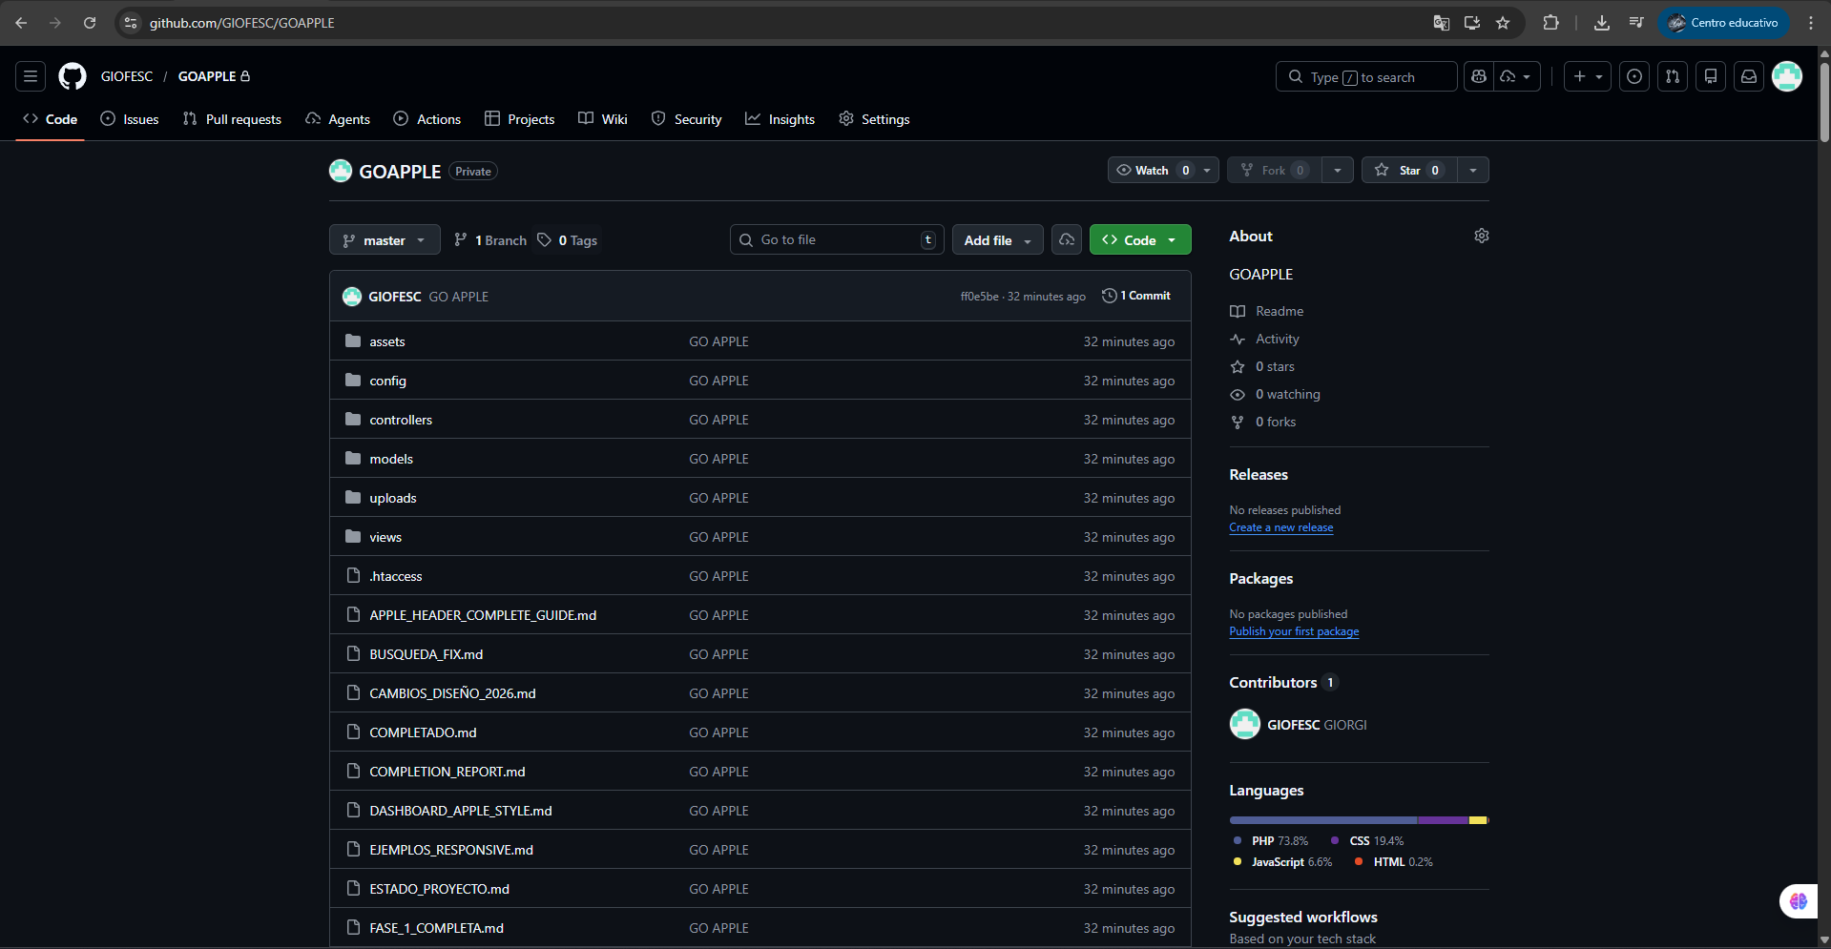

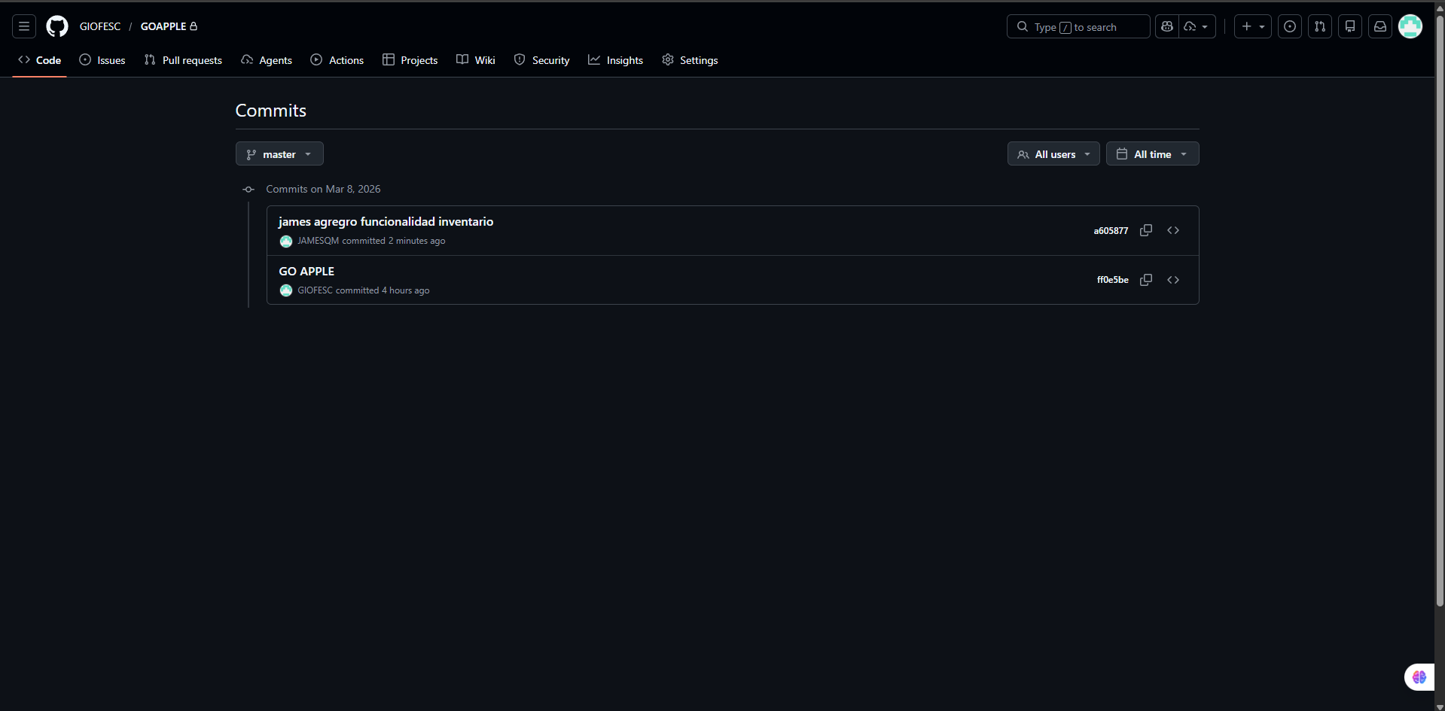
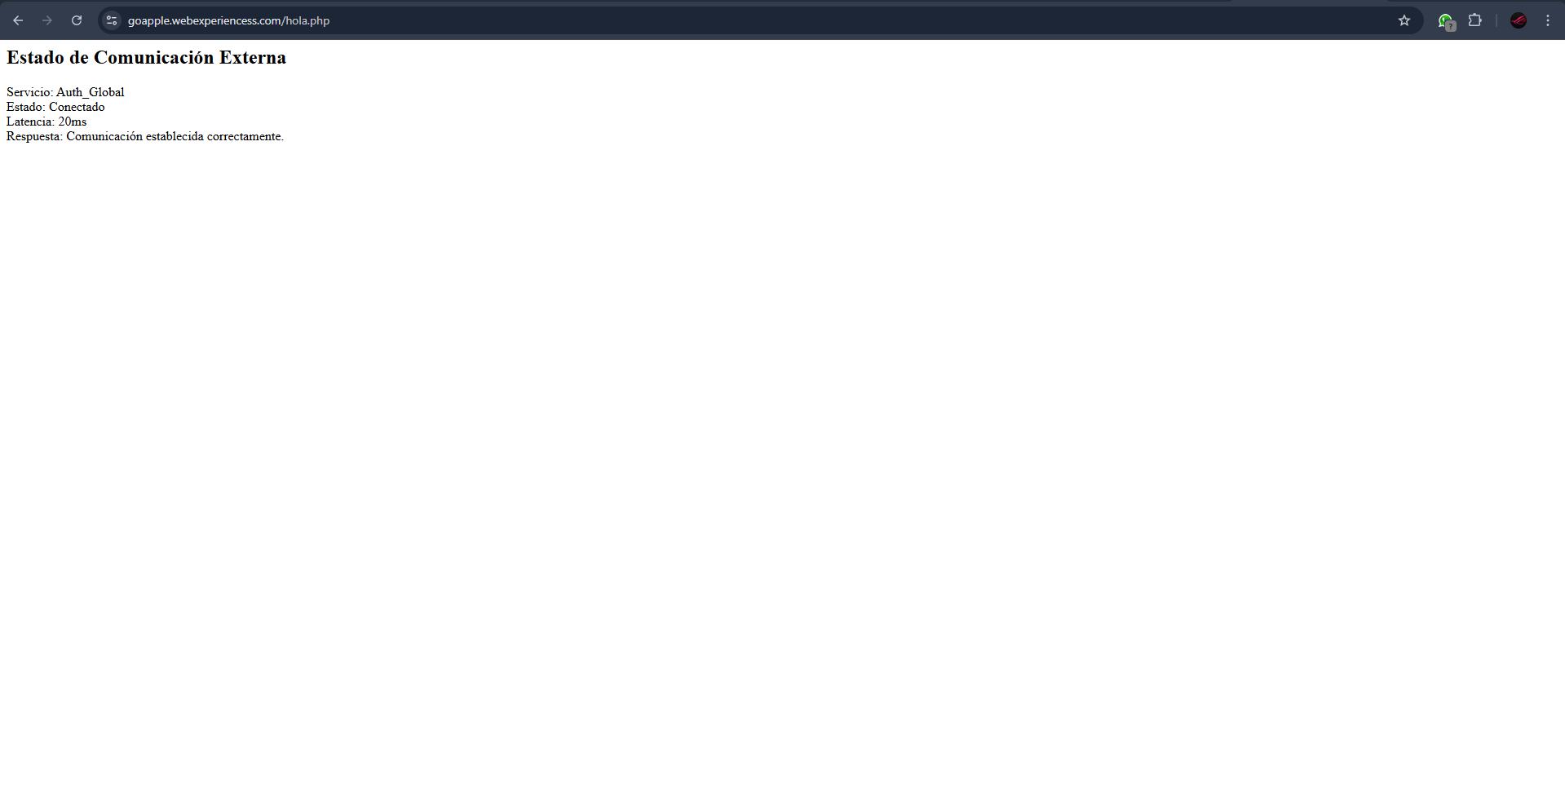

PRACTICAL GUIDE No. 2: FUNCTIONAL MODELING AND LAYER ARCHITECTURE

Activity 1: Interoperability Analysis (Middleware)

1.1 Middleware Concept in Distributed Systems
In a client-server architecture, middleware is the intermediate layer that enables communication between applications running on different machines. Its main function is to abstract network complexity, allowing developers to work as if the system components were in the same local environment.

1.2 Classic Middleware Models
RMI — Remote Method Invocation
Java RMI allows a program to invoke methods of objects running on another machine. A remote object is registered on the server; the client requests it and executes its methods as if they were local. Main advantage: invocation transparency without manually managing the network.
COM / DCOM
Component Object Model and its distributed extension DCOM allows Microsoft applications to share components between processes or different machines. It supports automatic serialization and was widely used in Windows enterprise environments.
Web Services
Web Services allow different applications to communicate over the internet using standard protocols (HTTP, XML, JSON), implemented as SOAP or REST. REST APIs with JSON have become the current standard for inter-system communication, and it is the model applied in GOapple POS.

1.3 Location Transparency
The location transparency principle establishes that the client does not need to know whether a service runs locally or on a remote server. The middleware hides the actual location of the service and manages communication. In GOapple POS, the user interacts with the application without knowing that processing occurs on the remote server.

Activity 2: Environment Configuration and Network Visibility
The development environment uses Windows with XAMPP (Apache + PHP + MySQL). The configuration focuses on:

Development Environment Configuration
• Create and configure the project in Visual Studio Code.
• Ubicar los archivos del proyecto en C:\xampp\htdocs\GOapple\.
• Verify that the directory is accessible at http://localhost/GOapple/.

Connectivity Verification
• Access the project domain from the browser.
• Verify that the Apache server responds correctly to HTTP requests.
• Confirm that the main script (index.php) runs without errors.

Activity 3: Logical Topology Design of the MVP
Component | Description
Client | User's web browser. Sends HTTP requests to the server.
Web Server | XAMPP/Apache on Windows. Interprets PHP and manages requests.
Web Application | PHP scripts that process requests. Data handled in JSON format.
Database | MySQL (included in XAMPP). Port 3306 on localhost.
Ports | Port 80 → Local HTTP | Port 443 → HTTPS

Logical network representation:
User
│
▼
Web Browser (Chrome / Firefox)
│
│ HTTP (Port 80) — localhost
▼
Web Server — XAMPP/Apache (Windows)
│
├── PHP Application → GOapple POS
│
▼
Database MySQL (Puerto 3306)

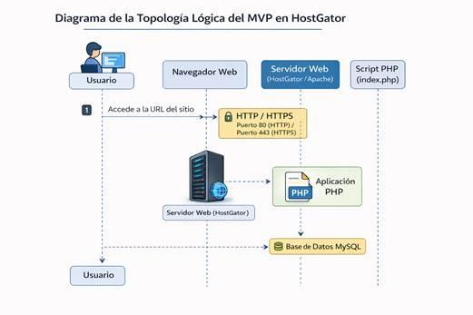
Figure 2.1. Logical topology of the GOapple POS system on Windows/XAMPP.

PRACTICAL GUIDE No. 3: PROCESS DESIGN AND WEB NAVIGATION

Activity 1: PHP Environment Verification on the Server
For the project development, a Windows environment with XAMPP was used, which includes native support for PHP and MySQL. In order to verify that the server correctly interprets PHP scripts, a test file was created to display the environment configuration.

Procedure Performed
7. Se creó el archivo info.php en el directorio C:\xampp\htdocs\GOapple\.
8. The following code was added:

<?php
phpinfo();
?>

9. The browser was accessed at http://localhost/GOapple/info.php.
10. The PHP environment configuration was correctly displayed, confirming that the server is enabled and running.

Activity 2: Creation of the Server Entry Point
The server.php file was created to simulate the server behavior within the client-server architecture. This file acts as an access point to receive requests from the browser.

Implemented file: server.php

<?php
echo "<h2>PHP Server Active</h2>";
echo "<br>";
echo "HTTP communication channel successfully established";
?>

This script represents the server component responsible for responding to client requests through the browser.

Activity 3: Client-Server Handshake Simulation
The Handshake process was simulated using the Request / Response communication model of the HTTP protocol. The browser acts as the client and the web server executes the PHP script to generate the corresponding response.

Implemented Communication Flow
11. The user accesses the website from their browser.
12. The browser sends an HTTP request to the server.
13. The server executes the server.php file.
14. The PHP script processes the request.
15. The server generates an HTML response.
16. The browser receives the response and displays it to the user.

Connection Test
To verify connectivity, the browser was accessed at:

http://localhost/GOapple/server.php

When the script was executed, the message was displayed: "PHP Server Active — HTTP communication channel successfully established", confirming that the client-server communication works correctly.

Practice Evidence
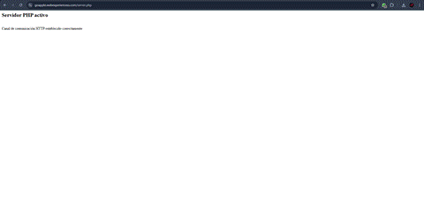
Figure 3.1. Message generated by the PHP server confirming active HTTP channel.
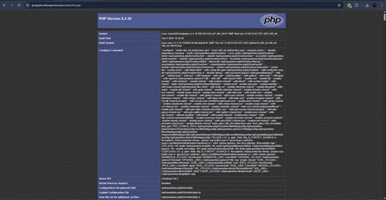
Figure 3.2. Browser accessing the server.php file of the GOapple POS project.

PRACTICAL GUIDE No. 4: STRUCTURAL LAYOUT AND SEMANTIC VALIDATION
Activity 1: Listening Algorithms (Listen & Accept)
The logic is implemented to allow the server to remain in an active waiting state and accept incoming connections. Apache (included in XAMPP) acts as a listener on port 80, delegating each accepted request to the PHP interpreter.

1.1 Equivalence: Traditional Socket vs. XAMPP/HTTP
Traditional Socket | HTTP/XAMPP Equivalent (Windows) | Application in GOapple POS
socket() | XAMPP starts Apache on Windows | Activated from XAMPP Control Panel
bind(puerto) | Apache listens on port 80 | localhost:80 → htdocs/GOapple/
listen() | Apache in active waiting state | POS system request queue
accept() | Apache accepts the HTTP request | Sales, credit, inventory request
fork/thread | Apache/PHP-CGI creates thread per request | Multiple simultaneous vendors

1.2 server.php — Extended Listening Point

<?php
/**
* GOapple POS — server.php
* Environment: Windows + XAMPP | Apache + PHP 8 | Port 80
*/

// STEP 1: Headers — listening channel
header('Content-Type: application/json; charset=UTF-8');
header('Access-Control-Allow-Origin: *');
header('Access-Control-Allow-Methods: POST, GET, OPTIONS');

// STEP 2: ACCEPT — identify HTTP method
$metodo = $_SERVER['REQUEST_METHOD'];
$ruta = $_SERVER['REQUEST_URI'];

if ($metodo === 'OPTIONS') { http_response_code(200); exit(); }

// STEP 3: LISTEN — log activity
error_log('['.date('Y-m-d H:i:s').'] Connection | '.$metodo.' | '.$ruta);

echo json_encode([
'status' => 'active',
'mensaje' => 'GOapple POS Server active. HTTP channel established.',
'metodo' => $metodo,
'hora' => date('Y-m-d H:i:s')
]);
?>

1.3 Execution Result
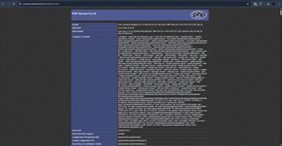
Figure 4.1. GOapple POS Server active — HTTP channel established on localhost.

Activity 2: Payload Exchange (Read/Write)

2.1 Payload Delimiters
Mechanism | Value / Configuration | Function
Content-Type | application/json; charset=UTF-8 | Defines the frame format
Content-Length | Automatically calculated by HTTP | Delimits the end of the payload in the buffer
Encoding | UTF-8 | Special character integrity
Method | POST (write) / GET (read) | Differentiates I/O operations
Logical delimiter | Key "accion" in the JSON | Identifies the business handler

2.2 WRITE — Client envía la trama

// CLIENT — JavaScript (views/sales/create.php)
async function registerSale(data) {
const payload = {
accion: "registrar_venta",
usuario_id: data.usuario_id,
cliente_id: data.cliente_id,
iphone_id: data.iphone_id,
tipo_venta: data.tipo_venta, // "Cash" | "Credit"
descuento: data.descuento,
forma_pago: data.forma_pago,
fecha: new Date().toISOString().split('T')[0]
};
const response = await fetch('http://localhost/GOapple/server.php', {
method: 'POST',
headers: { 'Content-Type': 'application/json; charset=UTF-8' },
body: JSON.stringify(payload)
});
const respuesta = await response.json();
manejarResponse(respuesta);
}

2.3 READ — Server receives and processes the frame

<?php
// SERVER — server.php (PHP 8)
header('Content-Type: application/json; charset=UTF-8');

// STEP 1: Read from network buffer
$raw = file_get_contents('php://input');
if (empty($raw)) { http_response_code(400); echo json_encode(['status'=>'error']); exit(); }

// STEP 2: Deserialize JSON
$datos = json_decode($raw, true);
if (json_last_error() !== JSON_ERROR_NONE) { http_response_code(400); exit(); }

// STEP 3: Route by logical delimiter
switch ($datos['accion'] ?? '') {
case 'registrar_venta': procesarVenta($datos); break;
case 'registrar_credito': procesarCredito($datos); break;
case 'consultar_inventario': consultarInventory($datos); break;
default: http_response_code(400); echo json_encode(['status'=>'error']); exit();
}
?>

2.4 System I/O Flow Table
Module | Operation | Action (payload) | Method | Response
Sales | WRITE/READ | registrar_venta | POST | venta_id + factura
Credits | WRITE/READ | registrar_credito | POST | credito_id + cuotas
Inventory | READ | consultar_inventario | GET | iPhone list
Clients | READ | buscar_cliente | GET | data + status
Payments | WRITE/READ | registrar_abono | POST | balance + receipt
Notifications | READ | obtener_notificaciones | GET | alert list

Activity 3: Close Protocol (Socket Close)

3.1 Server-Side Close (PHP)

<?php
// Explicit HTTP channel close
function enviarResponseYCerrar(array $datos, int $codigo=200): void {
$body = json_encode($data, JSON_UNESCAPED_UNICODE);
http_response_code($code);
header('Content-Type: application/json; charset=UTF-8');
header('Content-Length: ' . strlen($body));
header('Connection: close'); // Close instruction to client
echo $body;
flush();
if (session_status()===PHP_SESSION_ACTIVE) session_write_close();
exit();
}

// Safe MySQL connection close (PDO)
register_shutdown_function(function() {
Database::close(); // self::$instance = null
error_log('['.date('Y-m-d H:i:s').'] PHP process finished. Resources released.');
});
?>

3.2 Client-Side Close (JavaScript)

// AbortController — close management
class ClientGOapple {
constructor() {
this.ctrl = null;
this.URL = 'http://localhost/GOapple/server.php';
}
async enviar(payload) {
this.ctrl = new AbortController();
const timeout = setTimeout(() => this.close('Timeout 10s'), 10000);
try {
const res = await fetch(this.URL, { method:'POST',
headers:{'Content-Type':'application/json; charset=UTF-8'},
body: JSON.stringify(payload), signal: this.ctrl.signal });
clearTimeout(timeout);
return await res.json();
} catch(e) {
console.error('[GOapple]', e.message);
return null;
} finally { this.ctrl = null; }
}
close(reason='') { if(this.ctrl){ this.ctrl.abort(); this.ctrl=null; } }
}
const cliente = new ClientGOapple();
window.addEventListener('beforeunload', ()=>client.close('Page unloaded'));

3.3 Complete Socket Lifecycle
# | Event | Client | Server (XAMPP/PHP)
1 | Open | fetch() creates TCP connection | Apache (XAMPP) accepts (accept())
2 | HTTP Handshake | Sends headers + JSON payload | Verifies headers and Content-Length
3 | Write (WRITE) | Writes payload to buffer | Reads with file_get_contents()
4 | Processing | Awaits response | Executes PHP business logic
5 | Read (READ) | Receives response JSON | Writes with echo + flush()
6 | Server close | Receives Connection: close | session_write_close() + exit()
7 | Client close | AbortController releases resources | PHP destructor closes PDO
8 | Audit | console.log final status | error_log() logs close

3.4 Close Verification — Windows (CMD / PowerShell)

:: Verify port 80 (Apache LISTENING)
C:\> netstat -ano | findstr :80

:: Verify MySQL connections (port 3306)
C:\> netstat -ano | findstr :3306

:: Identify process on port 80 (PowerShell)
PS C:\> Get-Process -Id (Get-NetTCPConnection -LocalPort 80).OwningProcess
:: Expected: httpd.exe (Apache XAMPP)

:: View GOapple POS close log
C:\> type C:\xampp\htdocs\GOapple\logs\error.log

